HBL Power Systems Ltd, India | Technical Description for  relay interface box for ccb

TECHNICAL DESCRIPTION
FOR
Relay interface box (RIB) for ccb

Document Number: 5 16 27 0057
Version: 1.1

Date Published: 01-05-2024

Prepared By
HBL Power Systems Limited
Hyderabad

This document and its content are the property of HBL Power Systems Ltd, who alone reserves the right for distribution use and reproduction

DOCUMENT DATA SHEET

Title of Document | File Name | Pages | Figures | Tables
Technical Description for Relay Interface Box for CCB | Technical Description for Relay Interface Box for CCB | 20 | 2 | -

Prepared by | Reviewed by | Approved by
D Lovaraju  (Sr. Engineer) | JVV Prasad  (Manager) | Y.Subrahmanyam  (Head -Engineering)

Abstract
This document describes the features and functions of the Relay Interface Box and explains the design of the same.

DOCUMENT CONTROL SHEET
# | Name | Organization | Function | Level
1 | D Lova Raju | HBL | Engineering | Prepare
2 | JVV Prasad | HBL | Engineering | Verify
3 | Y. Subrahmanyam | HBL | Engineering | Approve

CHANGE HISTORY

# | Date | Reason for changes | Updated by | Version
1 | 01-02-2023 | Initial Draft | D Lovaraju | 1.0

GLOSSARY OF TERMS
# | Abbreviation | Meaning
 | BC | Brake Cylinder
 | BP | Brake Pipe
 | MR | Main Reservoir
 | CAN | Controller area network
 | LP-OCIP | Loco Pilot Operation Cum Indication Panel
 | EB | Emergency Brake
 | FR | Functional Requirement
 | FSB | Full-Service Brake
 | LV | Limiting Valve
 | MU | Multiple Unit
 | VEB | Vital Emergency Brake
 | SR | Safety Requirement
 | KAVACH(TCAS) | Train Collision Avoidance System
 | RIB | Relay Interface Box
 | EP | Electro Pneumatic
 | ATP | Automatic Train Protection System
 | BIC | Brake Interface Card
 | DC | Direct Current
 | CCB | Computer Controlled Brake

1.0 SCOPE 8
2.0 PURPOSE 8
3.0 CCB RIB FUNCTIONAL & SAFETY REQUIREMENTS 8
4.0 BRAKE APPLICATION ON LOCOMOTIVES 11
5.0 CCB RIB DESIGN DESCRIPTION 12
5.5 NORAML BRAKE(NB) 12
5.5.1 Normal Brake Application 12
5.5.2 Normal Brake Release 12
5.6 FULL-SERVICE BRAKE(FSB) 12
5.6.1 Full-Service Brake Application 12
5.6.2 Full Service Brake Release 12
5.7 EMERGENCY BRAKE(EB) 13
5.7.1 Emergency Brake Application 13
5.7.2 Emergency Brake Release 13
5.8 LIGHT ENGINE(LE) BRAKING 13
5.8.4 Normal Brake Application(LE mode) 13
5.8.5 Normal Brake Release (LE mode) 13
5.8.6 Full Service Brake Application (LE mode) 13
5.8.7 Full Service Brake Release (LE mode) 14
5.8.8 Emergency Brake Application (LE mode) 14
5.8.9 Emergency Brake Release (LE mode) 14
6.0 CCB RIB – Electrical Circuit 14
7.0 Electronics in CCB RIB 15
8.0 COMPLIANCE WITH SAFETY REQUIREMENTS 16
9.0 Dimensional details of CCB RIB 17
10.0 Technical Specification Sheets 17
11.0 Block Diagram of Relay Interface Box for CCB Locomotive. 18

- SCOPE
  - This document relates to the design of Relay Interface Box for use on CCB Locomotive and ATP systems like KAVACH.

- PURPOSE
  - KAVACH is designed to ensure safe train operation in the event of human failure by stopping or controlling the speed of trains.
  - For the sake of brevity, KAVACH will hereafter be referred to as ATP system.
  - It is necessary for ATP systems to be interfaced with the braking system of the Locomotive’s.
  - Under certain circumstances, it is also necessary to isolate the ATP system braking and allow the Loco Pilot to operate the Loco’s manually.
  - The purpose of this document is to propose the design of CCB RIB for ATP system that fulfills the above safety requirements.
- CCB RIB FUNCTIONAL & SAFETY REQUIREMENTS
  - The functional requirements of CCB RIB are listed below.
# | Requirements
FR-1 | CCB RIB shall work in parallel to the existing Locomotives braking system (controlled by the Pilot). The CCB RIB shall pass the brake command signals to TPM (Train protection module of M/s KBI) unit which been interfaced with loco CCB brake system.
FR-2 | CCB RIB shall not modify the existing braking characteristics of the Locomotives as well as other self-propelled vehicles treated as trains.
FR-3 | The CCB RIB shall have provision for executing following brake commands  a) Normal Brake (NB) command  NB –BP Pressure Drop to 4.4±0.1 kg/cm2 from 5.0 kg/cm2  b) Full Service Brake (FSB) command  FSB –BP Pressure Drop to 3.5±0.2 kg/cm2 from 5.0 kg/cm2  c) Emergency Brake (EB) command  EB – BP Pressure Drop to <0.3 kg/cm2 from 5.0 kg/cm2  d) Light engine brake command  Pressure build-up in Brake Cylinders to 3.5±0.1 kg/cm2
FR-4 | Based on the input signal received from the ATP system through CCB RIB, the existing brake control system shall apply the corresponding brake through TPM, as mentioned at FR-3 above.
FR-5 | Separate Relays shall be used for following brake applications  - Normal Brake  - Full-Service Brake  - Emergency brake  - Light Engine braking and  - QRV
FR-6 | On withdrawal of brake command from ATP system, the corresponding brake shall be released, and restoration of traction cutoff control shall be enabled.
FR-7 | There shall be a facility to override the "ATP system initiated braking" by the "driver’s braking" (or vice versa) to achieve higher braking intensity whenever required. Loco Pilot can override and increase braking effort generated by CCB RIB, but not decrease the same. Also, the lower braking intensity of KAVACH shall be overridden by a higher braking intensity produced by other train safety systems, if any.
FR-8 | CCB RIB shall be capable of receiving braking commands simultaneously from the Loco pilot through Brake Controller handle as well as from the ATP system at the same time. In case of multiple braking requests received simultaneously, the CCB RIB should implement the command demanding for the highest braking effort.
FR-9 | CCB RIB shall have provision to obtain feedback from existing system about the execution of braking command given to it by ATP system and communicate it back to ATP system.
FR-10 | CCB RIB shall have a provision of point-to-point communication with ATP system.
FR-11 | The communication between the CCB RIB and the ATP system shall be on RS-485. RS485 communication ports should have galvanic/optical isolation.
FR-12 | There shall be provision for Isolation of the complete CCB RIB. Isolation shall be provided in case of malfunction. After isolation, the normal brake characteristics of the locomotive brake system shall not be affected.
FR-13 | The CCB RIB shall have the facility to isolate itself from the loco pneumatic system through an isolation cock. The isolation shall be achieved through a valve electrically operated by the CCB RIB.
FR-14 | The Brake unit isolation shall be monitored, and its status shall be communicated by CCB RIB to ATP system.
FR-15 | The CCB RIB shall have a non-re-settable counter to register the instances of brake unit getting isolated by the Loco Pilot.
FR-16 | The CCB RIB isolation switch shall be located on the CCB RIB such that it is accessible for operation by the Loco Pilot.
FR-17 | There shall be a provision of manual isolation of the CCB RIB. Pneumatic inlet pipe BP to CCB RIB shall be provided with isolating cock to the unit.
FR-18 | CCB RIB shall have a Self-Test feature for the detection of failed sensors/relays by performing self-diagnosis at power ON and give alerts to a user through ATP system display. The CCB RIB shall have the facility to communicate its diagnostics information to ATP system.
FR-19 | CCB RIB shall have provision for redundant control for emergency brake command, which shall be activated if the default control mechanism fails
FR-20 | For any internal failure in CCB RIB, the following action shall be taken by CCB RIB.  - Brakes will be applied.  - System goes to failure mode.
FR-21 | All supply voltages for operating the CCBRIB shall be generated from loco battery which shall be in the range 78V to 136V DC

  - Requirements for data logging of braking events generated by equipment connected to communication ports (For ATP system).

# | Requirement
FR-22 | Recording of CCB RIB isolation event with date and time and number of counts of CCB RIB isolation.
FR-23 | Arrangement for data logging for the braking event shall be available with ATP system. The status of following events shall be logged at 1-sec interval/change in events, with date and time stamp  - ATP brake command active  - Isolation of CCB RIB  - CCB RIB failure log  - Relays failure log  - CCB RIB Brake command override by Loco pilot brake command, vice versa  - Any change in BP/BC greater than 0.3Kg/cm² to be logged
FR-24 | The facility for the storage of data log shall be for 90 days. An application running on PC shall be provided for downloading the Log and evaluating the same.

  - The safety requirements of CCB RIB are listed in the following table.
# | Requirements
SR-1 | The emergency brake command shall be fail-safe.
SR-2 | In case of power supply failure to CCB RIB, the emergency brake shall get activated.
SR-3 | In case of communication failure between CCB RIB and ATP System, the CCB RIB shall command emergency brake.
SR-4 | In case of critical failure of CCB RIB electronics interfaced with ATP System, emergency brakes shall get activated.
SR-5 | In the case of manual isolation of CCB RIB through the operation of BP cock, the isolation cock shall be provided with sensing input connected to CCB RIB to detect the external pneumatic isolation. This information shall be communicated by CCB RIB to ATP system to switch to the appropriate mode of operation.
SR-6 | There shall be a provision in CCB RIB to cut-off traction in Locomotives automatically whenever brake command signal is received to CCB RIB (through ATP system). Also, this shall be withdrawn as soon as brake commands are withdrawn.

- BRAKE APPLICATION ON LOCOMOTIVES
  - The brake system on a locomotive has two leversA9 and SA9, which the loco pilot uses to apply brake to train. In case the train is in formation, the brake lever A9 is used, while for a light engine SA9 is used.
  - The A9 Brake lever is a compact self-lapping, pressure maintaining brake valve which is capable of gradual application or release of locomotive and train brakes. A9 Automatic Brake Valve has five positions: RELEASE, RUN, MIN, FS and EMER. In the Release position, it provides a brake pipe pressure of 5 Kg/Cm2. In other positions, the brake pipe pressure is reduced to varying levels according to the required level of braking.
  - SA9 Independent Brake Valve is a compact self-lapping, pressure maintaining Brake Valve which is capable of gradual application or release of Locomotive Air Brakes independent of Automatic Brake. The SA9 Independent Brake Valve is also capable of releasing an automatic brake application on the Locomotive without affecting the train brake application. The SA9 Brake Valve has two positions: REL and FULL.

- CCB RIB DESIGN DESCRIPTION
  - In a locomotive, the Loco Pilot adjusts the position of A9 lever to obtain the desired level of braking based on situational awareness through sensory perception.
  - With automated or mechanized train systems, there should be an automated mechanism of controlling the brake pipe pressure to obtain the desired level of braking. The proposed CCB brake Interface Unit design facilitates this automated mechanism, which is described in the subsequent sections.
  - At the core of the CCB RIB consists of one interface card with external power supply. The CCB unit mechanism is assembled with electrically operated relays for braking application based on the brake command signal from ATP system.
    - There are four separate relays for each brake application namely NB relay for normal brake, FSB relay for Full-service brake and EB relay for emergency brake and LE relay for LE brake application.
    - There is one additional QRV relay to operate SIFA valve for emergency exhaust of Brake Pipe pressure.
  - The CCB RIB has a wiring/cable interface with TPM module to pass the brake command signals received from ATP system.

  - NORAML BRAKE(NB)
    - Normal Brake Application
      - By default, the NB relay in CCB RIB is in energized position.
      - Whenever a normal brake command is received from ATP system, the NB relay gets de-energized and it drops the NB signal low on TPM module, then the NB brake shall be applied through CCB Brake system.
    - Normal Brake Release
      - When NB brake release command received from ATP system, the NB relay in CCB RIB get energized and the NB signal in TPM module will becomes high and it releases the brake through CCB Brake system.
  - FULL-SERVICE BRAKE(FSB)
    - Full-Service Brake Application
      - By default, the FSB relay in CCB is in energized position.
      - Whenever a FSB brake command received from ATP system, the FSB relay get de-energized and it drops the FSB signal low on TPM module, then the FSB brake shall be applied through CCB Brake system.
    - Full Service Brake Release
      - When the FSB brake release command received from ATP system, the FSB relay in CCB RIB get energized and the FSB signal in TPM module will becomes high and it releases the brake through CCB Brake system.

  - EMERGENCY BRAKE(EB)
    - Emergency Brake Application
      - By default, the EB relay in CCB RIB is in energized position and the QRV relay in energized position.
      - Whenever a EB brake command is received from ATP system, the EB relay gets de-energized and it drops the EB signal low on TPM module, then the EB brake shall be applied through CCB Brake system.
      - Simultaneously, the QRV relay gets de-energized, and it drops the supply to SIFA valve. The BP pressure will exhaust through the exhaust port of SIFA valve.
    - Emergency Brake Release
      - When EB brake release command received from ATP system, the EB relay in CCB RIB get energized and the EB signal in TPM module will becomes high and it releases the brake through CCB Brake system.
      - Simultaneously, the QRV relay gets energized, and which energizes the SIFA valve and BP pressure will be blocked.

  - LIGHT ENGINE(LE) BRAKING
    - For the ATP system equipped loco, this awareness is available on the LP-OCIP (DMI), which requires the loco pilot to select whether the loco is pulling a formation or operating as a light engine.
    - When LE mode is selected by the Loco Pilot on the DMI, ATP uses the Light Engine brake for adequate braking.
    - There is one additional relay for LE mode of operation, which enables the LE signal on TPM module for LE brake application.
    - Normal Brake Application(LE mode)
      - By default, the NB relay and LE relay in CCB is in energized position.
      - Whenever a normal brake command is received from ATP system, the NB relay gets de-energized and it drops the NB signal low on TPM module, then the NB brake will be applied through CCB Brake system.
      - Simultaneously, the LE relay gets de-energized and it drops the LE signal low on TPM module and applies brake through CCB bake system.
    - Normal Brake Release (LE mode)
      - When NB brake release command received from ATP system, the NB relay in CCB RIB get energized and the NB signal in TPM module will becomes high and it releases the brake through CCB Brake system.
      - Simultaneously, the LE relay get energized and it enables the LE signal high on TPM module and LE brake will be released.
    - Full Service Brake Application (LE mode)
      - By default, the FSB relay and LE relay in CCB is in energized position.
      - Whenever a normal brake command is received from ATP system, the FSB relay get de-energized and it drops the FSB signal low on TPM module, then the FSB brake will be applied through CCB Brake system.
      - Simultaneously, the LE relay gets de-energized and it drops the LE signal low on TPM module and applies brake through CCB bake system.

    - Full Service Brake Release (LE mode)
      - When the FSB brake release command received from ATP system, the FSB relay in CCB RIB get energized and the FSB signal in TPM module will becomes high and it releases the brake through CCB Brake system.
      - Simultaneously, the LE relay gets energized and it enables the LE signal high on TPM module and LE brake will be released.
    - Emergency Brake Application (LE mode)
      - By default, the EB relay in CCB RIB is in energized position and the QRV relay in energized position.
      - Whenever a EB brake command is received from ATP system, the EB relay gets de-energized and the EB signal on TPM module will becomes low, then the FSB brake shall be applied through CCB Brake system.
      - Simultaneously, the QRV relay gets de-energized and it drops the supply to SIFA valve. The BP pressure will exhaust through the exhaust port of SIFA valve.
      - At the same time the LE relay also get de-energized and it drops the LE signal low on TPM module and applies the LE brake through CCB brake system.
    - Emergency Brake Release (LE mode)
      - When EB brake release command received from ATP system, the EB relay in CCB RIB get energized and the EB signal on TPM module will becomes high and it releases the brake through CCB Brake system.
      - Simultaneously, the QRV relay gets energized, and which energizes the SIFA valve and BP pressure will be blocked.
      - At the same time LE relay also gets energized and it enables the LE signal high on TPM modules and releases the LE brakes through CCB brake system.

- CCB RIB – Electrical Circuit
  - The CCB RIB electrical circuit consists of a micro controller based electronic brake interface card and an Isolation Switch.
  - Pressure sensors in critical areas of the braking system provide feedback to the BIC card for health monitoring and reporting.
  - For connecting with ATP system vital computer, a separate serial port based RS485 interface is provided.
  - All the relays are controlled through software in the brake interface card. The relays are controlled by the CCB RIB as per braking commands received from ATP system. Therefore, these relays operate only when the CCB RIB is in service mode.
  - Whenever the isolation switch is in isolation mode the all the relays in RIB are in energized state to enable the all brake signals high to the TPM module and the SIFA emergency valve’s remain in energized position irrespective of Isolation switch position.
  - The following table shows the conditions of each relay under various braking applications. Here, the letter E indicates that the relay is energized, while D indicates that the relay is de-energized.

Position | NB  Relay | FSB  Relay | EB  Relay | LE  Relay | QRV  Relay | Traction cut-off  Relay
A9-Release | E | E | E | E | E | E
A9-NB Brake | D | E | E | E | E | D
A9-FSB Brake | E | D | E | E | E | D
A9-Emergency Brake | E | E | D | E | D | D
SA9-Release | E | E | E | E | E | E
SA9-Application | E | D | E | D | E | D
SA9-Emergency Brake | E | E | D | D | D | D
CCB RIB isolation | E | E | E | E | E | E

- Electronics in CCB RIB
The figure below shows the interface of electronic modules in CCB RIB
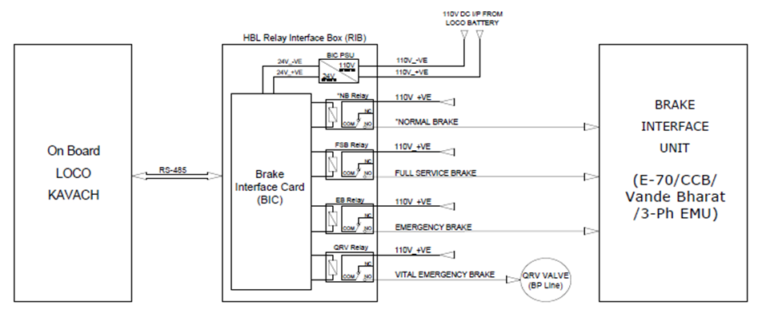
  - Brake interface card (BIC).
    - The brake interface card is the heart of the BIU system. This module is micro-controller based and performs the following functions.
    - The BIC card interfaces with ATP system on RS-485 communication link using optically isolated ports.
    - BIC controls the relays for commanding the formation and LE braking operations, as explained above in sections 5 and 6. The brake commands are received from ATP system
    - For any brake application, the BIC card energies/de-energies the corresponding relay which also cuts off traction. When brake is released, these outputs are withdrawn.
    - The air pressure in MR, BP and BC is sensed by BIC through pressure sensors.
    - BIC card Interfaces with an electro-mechanical counter for registering the number of times RIB is isolated.
    - BIC receives feedback from BP isolating cock when operated (Open / Close).
  - BIC power supply card
    - BIC power supply card that converts the loco battery supply 110V to 24 volts DC output.
    - BIC power supply card is used for powering the relays.

- COMPLIANCE WITH SAFETY REQUIREMENTS
  - Fail Safety
    - If there is loss of electric power, CCB RIB automatically applies emergency brake through the SIFA emergency valve.
    - If there is a loss of communication between ATP system and CCB RIB, the CCB RIB will automatically apply emergency brake.
    - For any brake application, CCB RIB activates a control signal that is used externally in the loco system for generating traction cut off.
  - Health Monitoring
    - CCB RIB electronics circuit includes power supply health monitoring and appropriate corrective actions.
    - Heart-beat monitoring of relays:
      - Brake Interface Card in CCB RIB monitors voltage and current of each energized relay for every 200ms.
      - If the voltage and current values of any relay cross defined tolerance limits, the corresponding relay is flagged as unhealthy.
      - In such an event, KAVACH displays a message on the DMI that the CCB RIB is unhealthy (<BRAKE Fault>) and will apply Emergency Brake.
      - The same event shall be recorded by ATP system.

  - Isolation
    - The CCB RIB can be electrically isolated by the use of an isolation switch provided on the front panel of CCB RIB.
    - The isolation switch can be changed from service to isolation mode.
    - Upon isolation, the original pneumatic circuit of the loco will function under control of the Loco Pilot.
    - RIB electronics will communicate to the ATP system that the RIB had been isolated. This causes the ATP systems to switch to an appropriate mode of operation, as per ATP system specification. RIB can also be isolated from the pneumatic system through operating cock installed in the BP line.
    - KAVACH will switch to Standby mode if either of the cocks is not in respective positions.

In this condition, KAVACH does not provide train protection features.

- Dimensional details of CCB RIB
  - Without mounting arrangement
The external dimensions of CCB RIB are 479(W) x 488(H) x 192(D) mm. The figure below shows the CCB RIB without the mounting arrangement.
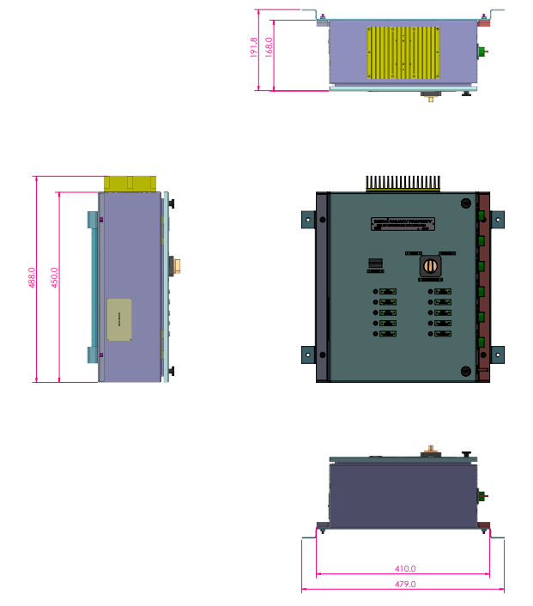
- Technical Specification Sheets
# | Item | Reference data sheet
1 | Relays | 
2 | Pressure Sensors | 

- Block Diagram of Relay Interface Box for CCB Locomotive.
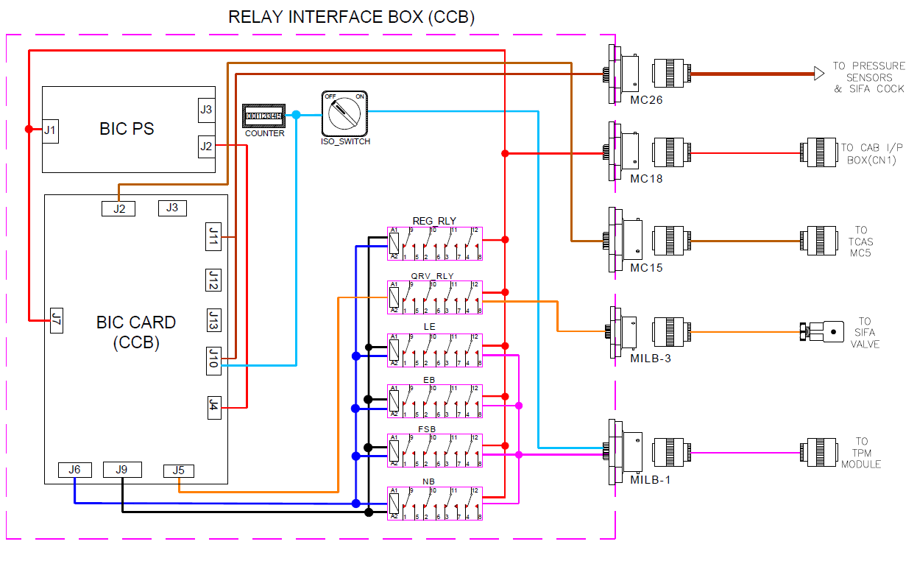
Figure 1: Block Diagram of Relay Interface Box for CCB Locomotive.

